# Practical 1

**Aim :- Program to calculate number of samples required for an image**

**Code** :- clc ; close ;

*// dimesion of the image in inches* m = 6; n = 4;

N = 100;

N2= N*N ; *// Number of dots per inch in both direction*

Fs= m* n * N2 ;

disp ( Fs , 'Number of samples requried to preserve the information in the image')

**output** :-

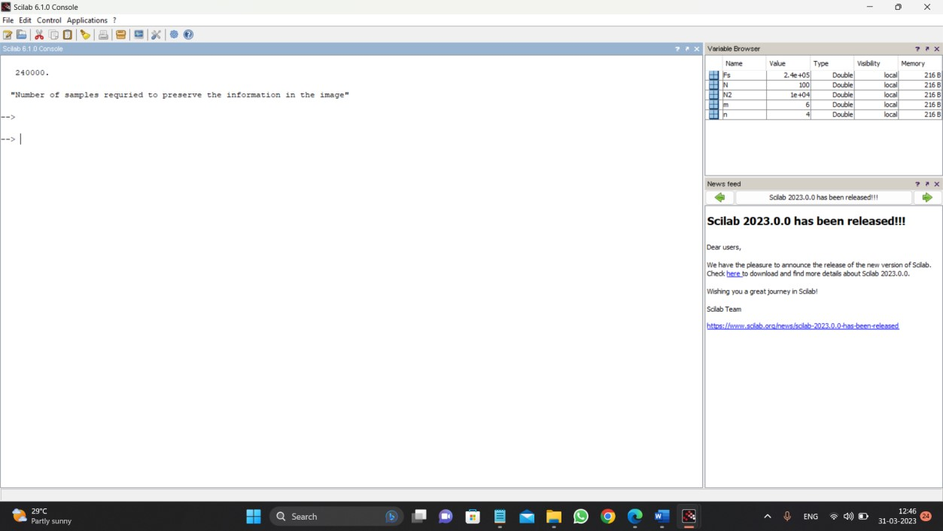

# Practical 2

**Aim :- Program to study the effects of reducing the spatial resolution of a digital image.**

**Code** :- clc;

clear all;

Img1=imread('lena.png');

Img = rgb2gray(Img1);

*//512*512*

subplot (2,2,1),imshow(Img),title('Og image 512*512');

*//256*256* Samp=zeros(256); m=1; n=1; for i=1:2:512 for j=1:2:512 Samp(m,n)=Img(i,j); n=n+1; end n=1; m=m+1; end

SampImg256=mat2gray(Samp);

subplot(2,2,2);

imshow(SampImg256);

title('Sampled.Img256*256')

*///////*

Samp=zeros(128); m=1; n=1; for i=1:4:512 for j=1:4:512 Samp(m,n)=Img(i,j); n=n+1; end n=1; m=m+1; end

SampImg128=mat2gray(Samp);

subplot(2,2,3),imshow(SampImg128),title('Sampled.Img128*128')

*//////////////////////*

Samp=zeros(64); m=1; n=1; for i=1:8:512 for j=1:8:512 Samp(m,n)=Img(i,j); n=n+1;

end n=1; m=m+1;

end

SampImg64=mat2gray(Samp);

subplot(2,2,4),imshow(SampImg64),title('Sampled.Img64*64')

**Output** :-

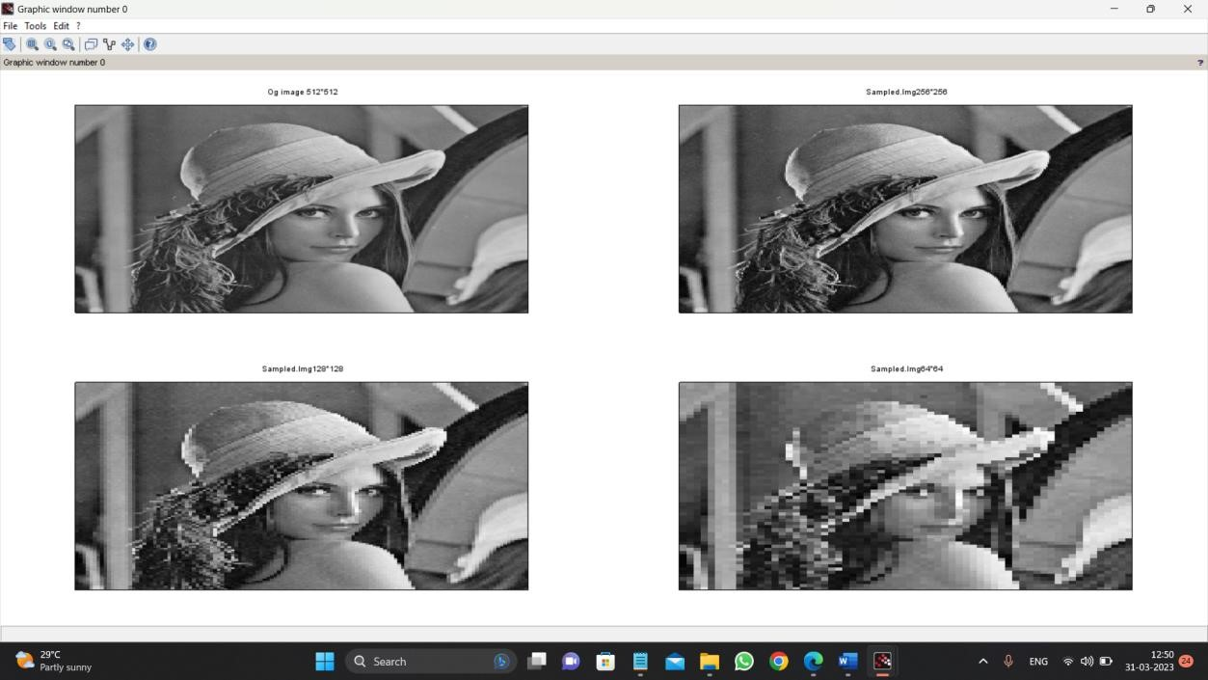

# Practical 3

**Aim :- Program to perform threshold on an image.**

**Code** :- clc; clear all; a=imread('lena.jpeg'); a=rgb2gray(a); subplot(2,1,1);

imshow(a);

title('org img');

T=100; *//threshold value*

[r,c]=size(a); for i=1:r for j=1:c if (a(i,j)<=T) x(i,j)=0; else x(i,j)=255;

end end end x=uint8(x);

subplot(2,1,2); imshow(x);

title('threshholded img');

**Output** :-

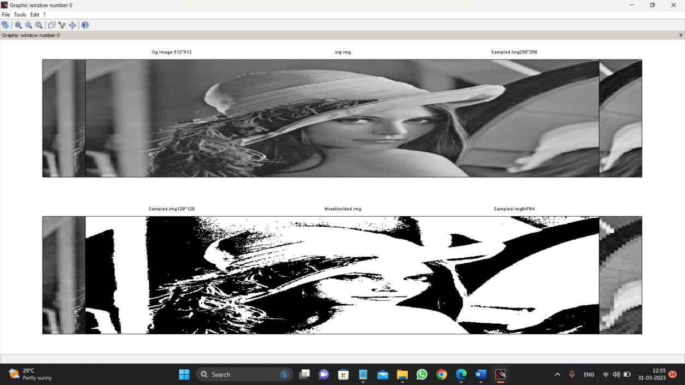

# Practical 4

**Aim :- Gray-level slicing with and without background.**

**Code** :- clc;

clear all;

a=imread('camera.png');

a1=58; *// This value is user defined* b1=158; *// This value is user defined*

[r,c]=size(a); figure(2); subplot(2,1,1); imshow(a); for i=1:r for j=1:c

if (a(i,j)>a1 & a(i,j)<b1)

x(i,j)=255; else

x(i,j)=a(i,j); end end end x=uint8(x); subplot(2,1,2);

imshow(x);

**Output** :-

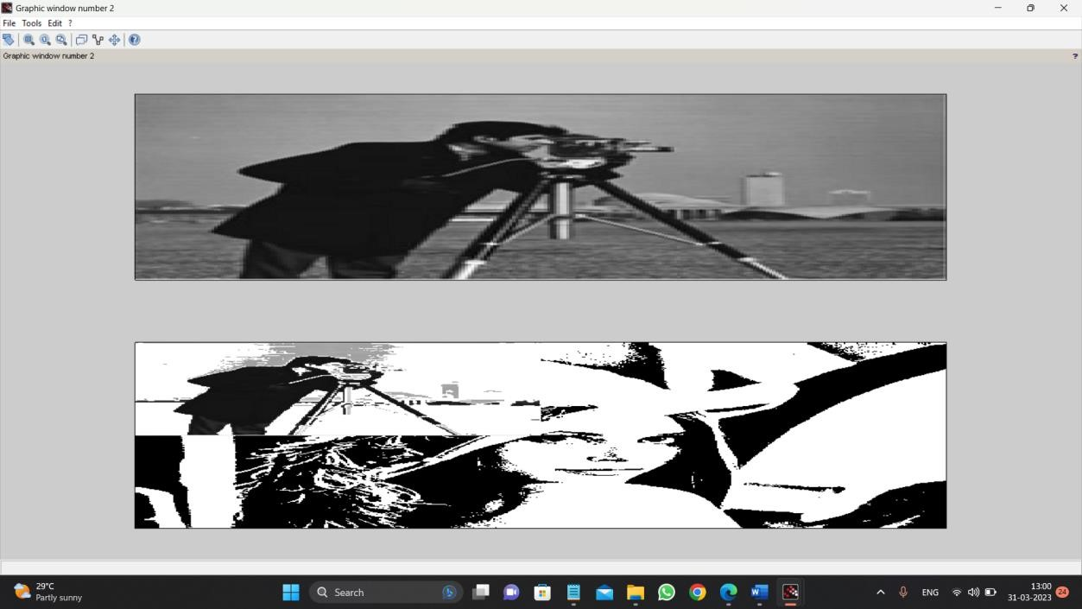

# Practical 5

**Aim :- Program to perform Image negation.**

**Code** :- *//for gray image*

A = imread('camera.png'); A=rgb2gray(A); subplot(2,1,1); imshow(A);

title('Original Image ');

[row col]=size(A); for x=1:row for y=1:col

A(x,y)=255-A(x,y);

end end subplot(2,1,2); imshow(A);

title('Image after negation');

**Output** :-

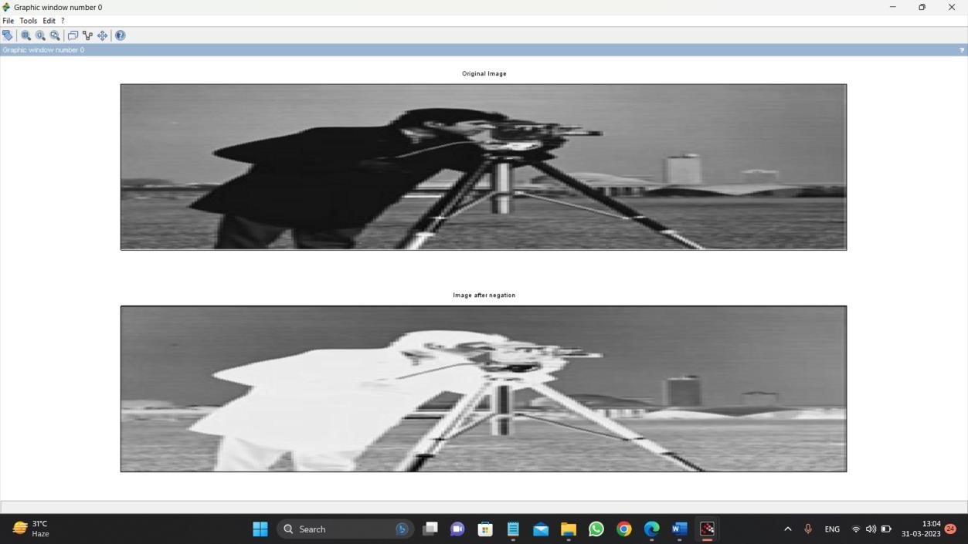

# Practical 6

**Aim :- Program to perform Image negation(color image).**

**Code** :- A = imread('negimg.jpg');

subplot(2,1,1);

imshow(A);

title('Orignial Image');

R = A(:,:,1);

G = A(:,:,2);

B = A(:,:,3);

[row col]=size(A); for x=1:row for y=1:col

R(x,y)=255-R(x,y);

G(x,y)=255-G(x,y); B(x,y)=255-B(x,y);

end end

A(:,:,1)=R;

A(:,:,2)=G;

A(:,:,3)=B;

subplot(2,1,2);

imshow(A);

title('Image after negation');

**Output** :-

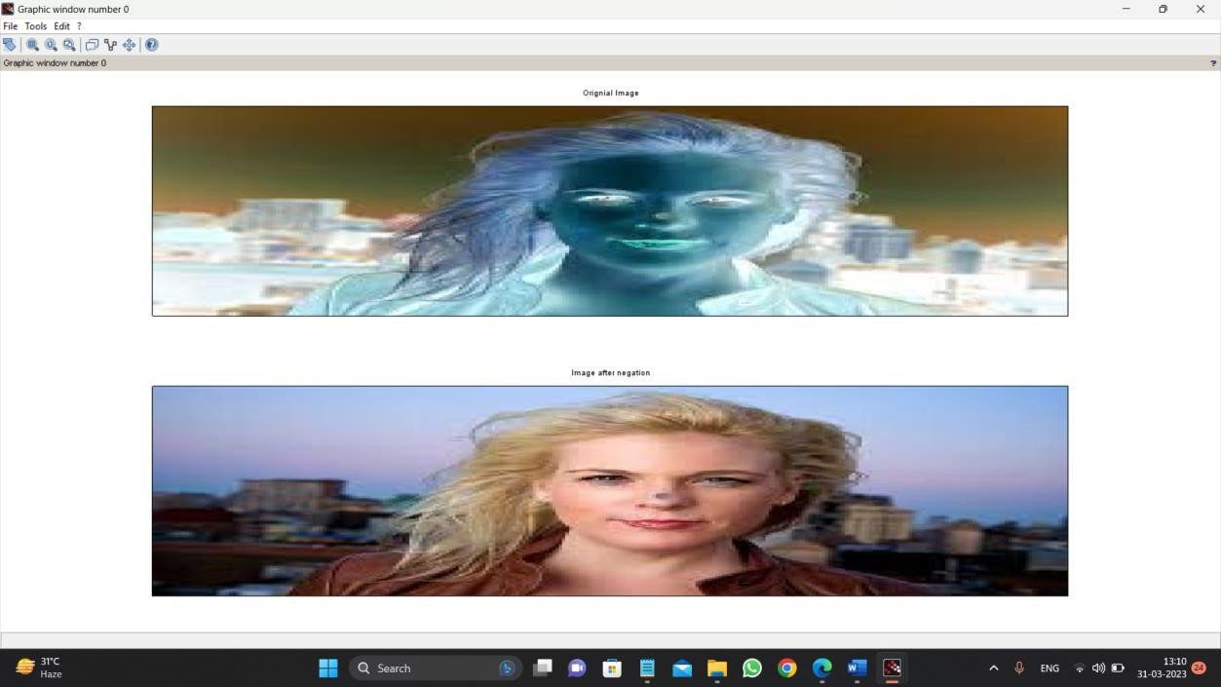

# Practical 7

**Aim :- Program to study the effects of varying the number of intensity levels in a digital image.**

**Code** :- clc;

clear all;

figure(1)

subplot(3,3,1); i=imread('lena.jpeg'); imshow(i); title('original image'); subplot(3,3,2); j1=imresize(i,0.8); imshow(j1);

title('resized image 0.8');

subplot(3,3,3); j2=imresize(i,0.7); imshow(j2);

title('resized image 0.7');

subplot(3,3,4); j3=imresize(i,0.6); imshow(j3);

title('resized image 0.6');

subplot(3,3,5); j4=imresize(i,0.1); imshow(j4);

title('resized image 0.1');

**Output** :-

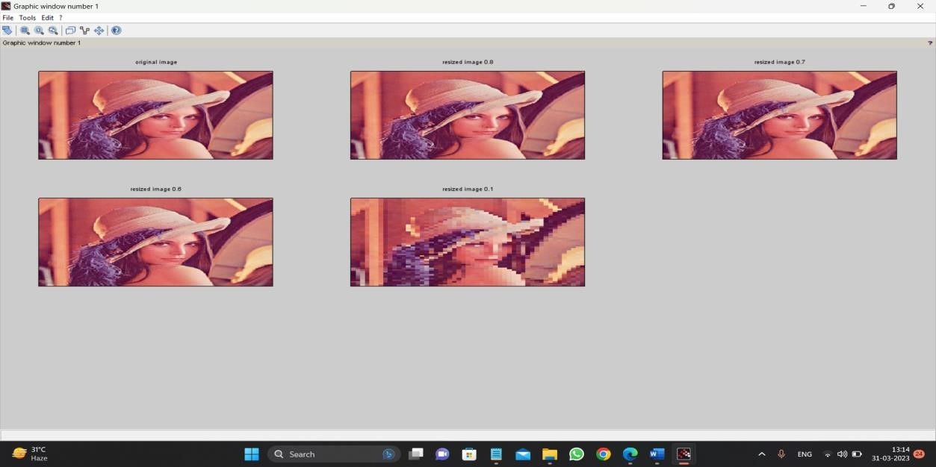

**Practical 8**

**Aim :- Program to perform Log transformation.**

**Code** :- clc; clear all; a=imread('camera.png'); a=rgb2gray(a); subplot(2,1,1); imshow(a); s=a; c=1; [r1,c1]=size(a); for i=1:r1 for j=1:c1 b=double(a(i,j)); s(i,j)=c*log10(1+b);

end

end

new1=uint8(s*100); *//imshow(new1);* subplot(2,1,2);

imshow(new1);

**Output** :-

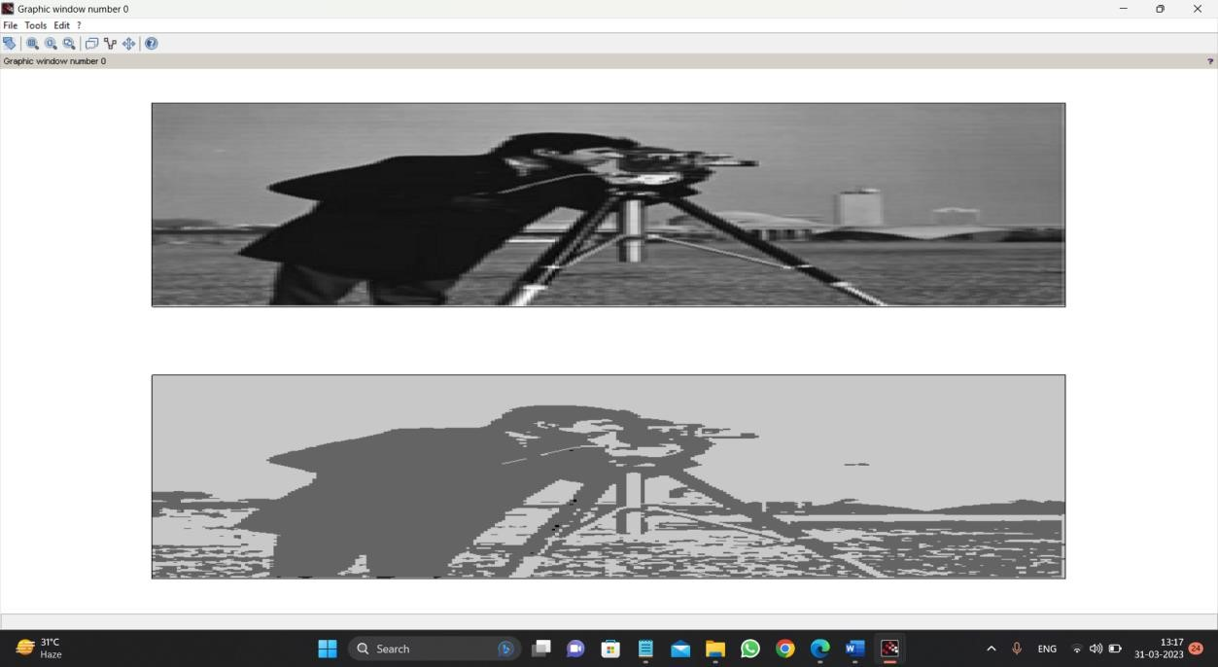

**Practical 9 9-Power-law transformations.**  clc;

a=imread('camera.png');

[r,c]=size(a); subplot(2,1,1); imshow(a); x=a; G=0.8;

for i=1:r for j=1:c b=double(a(i,j)); x(i,j)=b^G; end

end new1=uint8(x); subplot(2,1,2);

imshow(new1);

**Output** :-

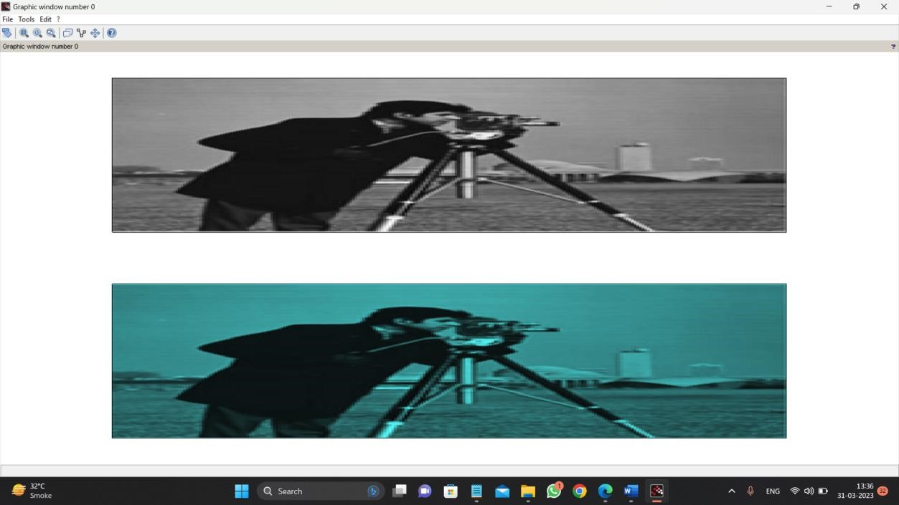

**Practical 10**

**Aim :- Program to plot the histogram of an image.**

**Code** :- clc; clear all; a=imread('lena.jpeg'); a=rgb2gray(a); h=zeros(1,258); [r,c]=size(a); for i=1:r for j=1:c if (a(i,j)==0) h(0)=h(0)+1;

end k=a(i,j); h(k)=h(k)+1; end end figure(1); subplot(1,2,1); imshow(uint8(a)); title('Original Image') subplot(1,2,2); bar(h);

title('Image histogram');

**Output** :-

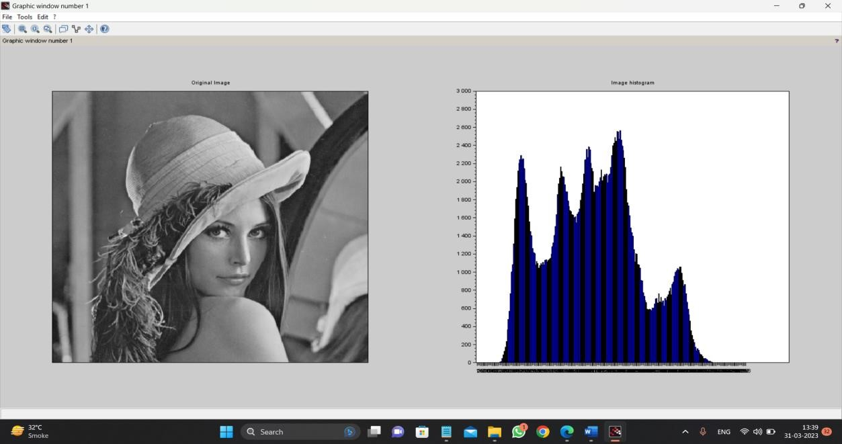

**Practical 11 Program to apply dilation**  clc;

a=imread('rectb.png'); a=rgb2gray(a); d=a;

A1=a;

[r,c]=size(d); subplot(2,1,1); imshow(a);

title('org img'); m=[1 1 1;1 1 1;1 1 1]; *// m=ones(5,5);* for i=2:1:r-1 for j=2:1:c-1

new=[(m(1)*d(i-1,j-1)) (m(2)*d(i-1,j)) (m(3)*d(i-1,j+1)) (m(4)*d(i,j-1))

(m(5)*d(i,j)) (m(6)*d(i,j+1)) (m(7)*d(i+1,j-1)) (m(8)*d(i+1,j))

(m(9)*d(i+1,j+1))]; A1(i,j)=max(new); end subplot(2,1,2);

imshow(A1);title('Processed Image - dilation'); end

**Output** :-

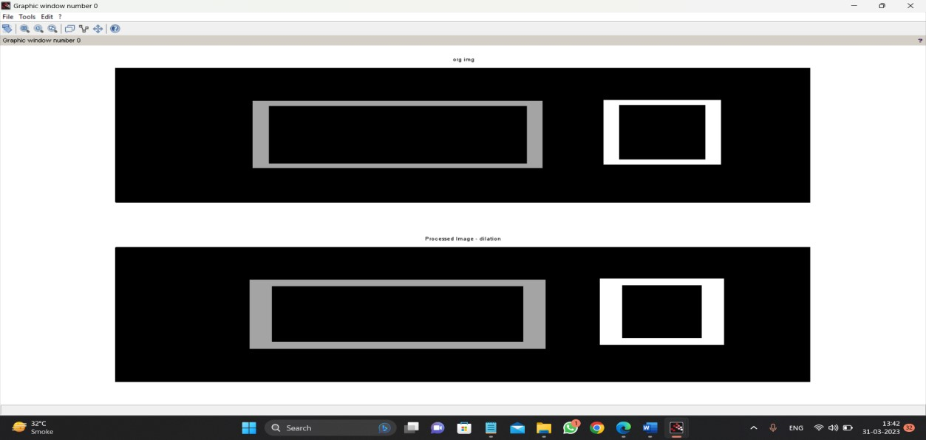

**Program to apply erosion.**

a=imread('rectb.png'); a=rgb2gray(a); subplot(2,1,1); imshow(a);

title('org img');

A1=a; d=a; [r,c]=size(d); m=[1 1 1;1 1 1;1 1 1]; *// m=ones(5,5);* for i=2:1:r-1 for j=2:1:c-1

new=[(m(1)*d(i-1,j-1)) (m(2)*d(i-1,j)) (m(3)*d(i-1,j+1)) (m(4)*d(i,j-1))

(m(5)*d(i,j)) (m(6)*d(i,j+1)) (m(7)*d(i+1,j-1)) (m(8)*d(i+1,j))

(m(9)*d(i+1,j+1))]; A1(i,j)=min(new); end subplot(2,1,2);

title('org img');imshow(A1);title('Processed Image - Erosion'); end

**Output** :-

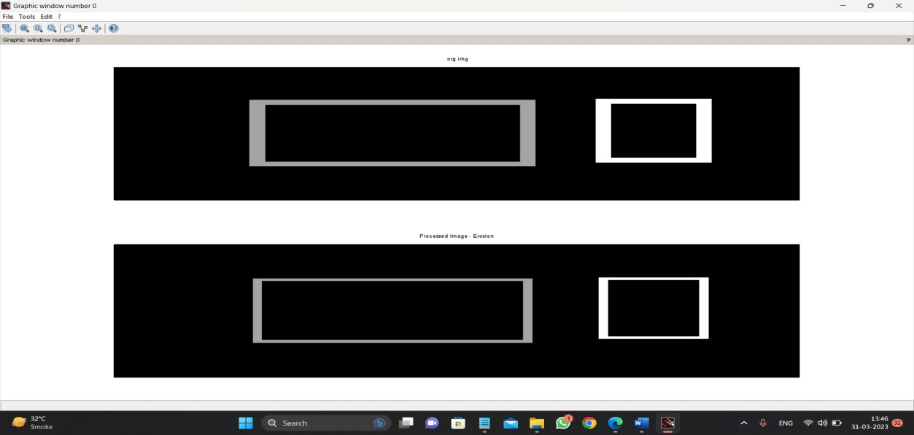

**Program for detecting boundary of an image.**  clc;

a=imread('rectb.png'); a=rgb2gray(a); subplot(2,1,1); imshow(a);

title('org img'); d=a; [r,c]=size(d); m=[1 1 1;1 1 1;1 1 1]; for i=2:1:r-1 for j=2:1:c-1

new=[(m(1)*d(i-1,j-1)) (m(2)*d(i-1,j)) (m(3)*d(i-1,j+1)) (m(4)*d(i,j-1)) (m(5)*d(i,j)) (m(6)*d(i,j+1))

(m(7)*d(i+1,j-1)) (m(8)*d(i+1,j)) (m(9)*d(i+1,j+1))];

A2(i,j)=min(new);

aa(i,j)=d(i,j)-A2(i,j);

end end subplot(2,1,2);

imshow(aa);title('Boundary Extracted Image');

**Output** :-

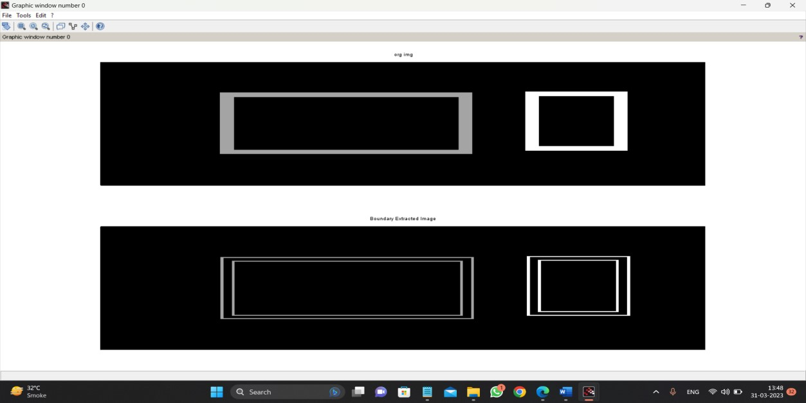

# Program to apply false colouring(pseudo) on a gray scale image

**Code**  clc; close;

a = imread('lena.jpeg');

*//Displaying Original RGB image*

figure(1); imshow(a);

title("Original Image")

*//Displaying Gray level image* b = rgb2gray(a);

figure(2); imshow(b);

title("Gray Level Image")

*//Displaying False coloring(Pseudo) image* figure(3) imshow(b,jetcolormap(256));

title("Pseudo Color Image");

**Output** :-

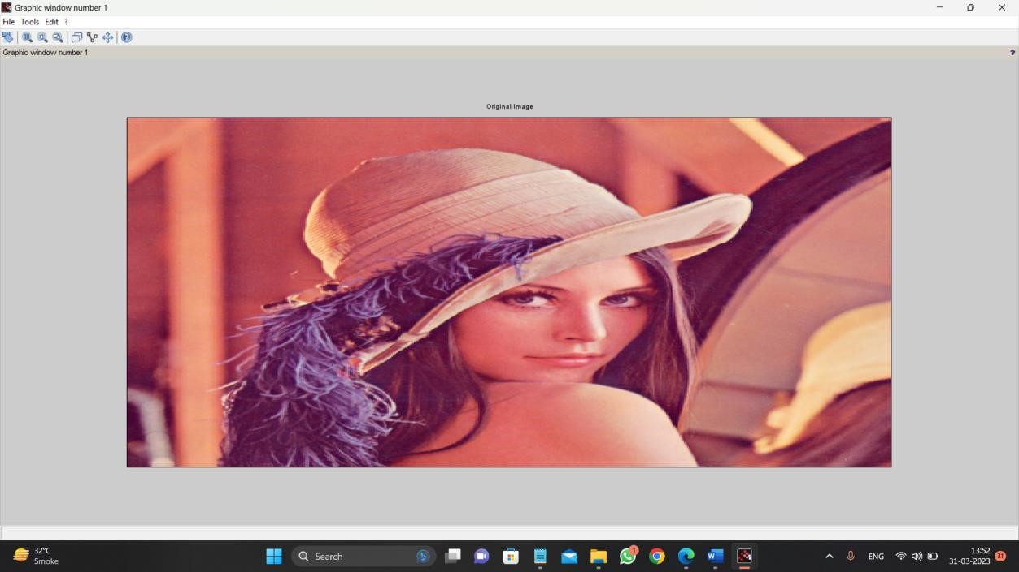

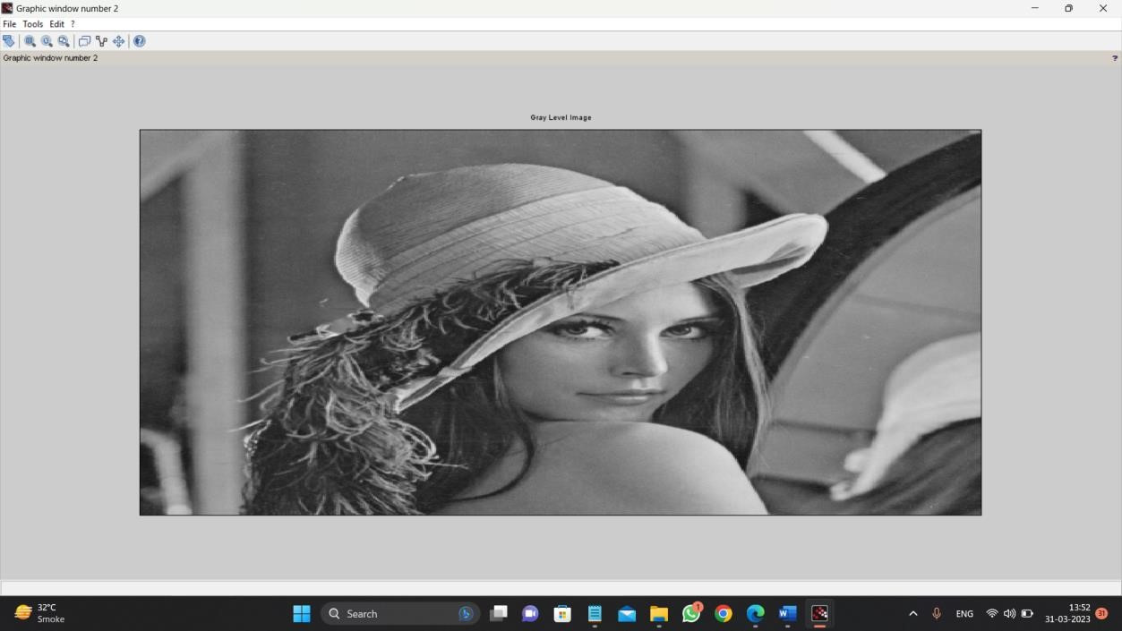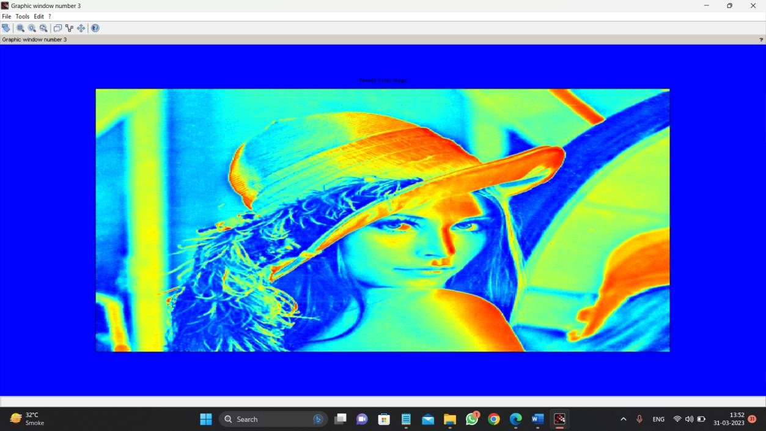

# Practical 15

**Aim :- Program to apply color to gray image**

**Code** :- clc;

close;

a = imread('lenag.jpeg');

*//Displaying Original RGB image*

figure(1); imshow(a);

title("Original Image")

*//Displaying Gray level image* b = rgb2gray(a); figure(2); imshow(b);

title("Gray Level Image")

*//Displaying False coloring(Pseudo) image* figure(3) imshow(b,jetcolormap(256));

title("Pseudo Color Image");

**Output** :-

